**HTML video loop Attribute**

Last Updated : 08 Oct, 2024

The **HTML <video> loop Attribute** is used to restart the video again and again after finishing it. It contains the Boolean value.

*The loop attribute is a boolean value.*

**Syntax:**

<video loop>

**Example:** This example shows the use of the HTML video loop attribute.



1

<!DOCTYPE html>

2

<html>

3

​

4

<head>

5

<title>HTML video loop Attribute</title>

6

</head>

7

​

8

<body>

9

<center>

10

<h1 style="color:green;">GeeksforGeeks</h1>

11

​

12

<h3>HTML video loop Attribute</h3>

13

​

14

<video width="400" height="200" controls loop>

15

<source src=

16

"https://media.geeksforgeeks.org/wp-content/uploads/20190616234019/Canvas.move_.mp4"

17

type="video/mp4">

18

<source src=

19

"https://media.geeksforgeeks.org/wp-content/uploads/20190616234019/Canvas.move_.ogg"

20

type="video/ogg">

21

</video>

22

</center>

23

</body>

24

​

25

</html>

**Output:**

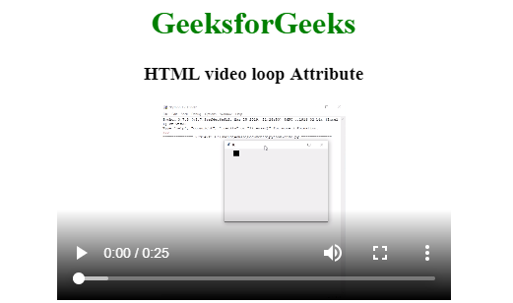

***Note:*** *Always specify the width and the height of the video else web page will be confused that how much space that video will be required due to that reason web page become slow down.*